WHAT IS INODE (index) number of a file -> is like a “finger-print”, unique for each file on the Linux file system.

i-node is an index (data structure) that provides information about the file such as if the file is a directory or regular file, etc.

running ls -i will display the i-node of files/directories

Hard links

* Reference to the same index (physical data) on a file system
* Creates a file that shares the same i-node number with original file
* Good way to back up your file, as long as one hard link remains, the data is preserved.
* Change original file, changes all other files that are hard-linked
* Disadvantage is that they take-up extra space, and cannot hard link directories (only files).
* Cannot hard link files from other unix/linux servers

Symbolic (soft) links

* Indirect pointer to a file. Contains the pathname to the original file
* Like a shortcut to other files. Can create symbolic links on different unix/linux servers, and also for directories
* Not good for backup purposes, if you delete the original file, data is lost and the symbolic link will point to a nonexistent file (broken link)

Managing processes

All commands/programs (tasks) that are running on Unix/Linux system are referred to as processes.

* Each process has an owner
* Each process has a unique ID (PID)
* Processes keep their PID for their entire life
* Usually a parent sleeps when a child is running
* Hierarchical

Commands used to manage processes

ps -> displays snapshot information about processes, basic listing of processes in current user’s terminal, such as PID, process names

ps -l -> detailed listing in current user’s terminal, such as PID, PPID (parent PID), status

ps -ef -> detailed listing ALL processes running on entire system

ps aux -> detailed listing of processes for ALL users and background running services

ps -U username -> basic listing of processes running for a particular user

top -> provides a realtime status of running processes, ctrl-c to exit

ctrl-c -> terminates a process running in the foreground

ctrl-z -> sends a process running in the foreground to the background

fg -> moves a background job from the current environment into the foreground, fg %job-number

bg -> runs the most recent process that was placed into the background, bg %job-number

jobs -> displays the status of jobs

kill -> kills the process(job), kill PID, kill -9 PID, kill %job-number, kill -9 %job-number

Foreground vs background processes

* Command & - will run the command in the background

ALIASES

* Is a nickname to an existing command or group of commands
* Lasts only for the current session, it will be lost when you log out from the session
* Can make it permanent by adding it to .bashrc file

Command history

.bash_history in your home directory stores recently executed command lines

fc -l -> displays last 16 commands

history | more -> display all stored commands

!num -> re-execute an issued command number by command number

!xxx -> re-run a most recent previously-issued command beginning with string “xxx”

kill %3: kill 3rd process

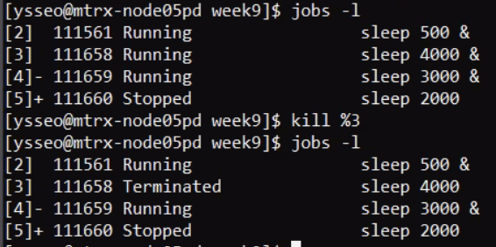

kill PID

bg %1 : bring the 1th process back to foreground

ctrl – z bring the process to background

broken link

symbolic link (content sync)

hard link (content sync)

